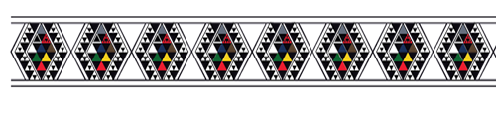
April 2023 | www.inlinehockeynz.org.nz

Matariki Weekend Friday 14 - Sunday 16 July 2023
New Plymouth

As part of the IHNZ Matariki hockey festival the leadership groups within the Matariki teams, will again invite our rangatahi from around NZ to compete in these teams and participate in a series of inline hockey games over the weekend. This creates a fantastic opportunity for our up and coming players to play with, and be mentored by the premier players of our game.

These players need to display:
- good sportsmanship, humility, respect towards teammates and officials and most importantly a great attitude where they are willing to listen and learn.
- The expectation is that they have at a minimum regional experience and potentially have been chosen for national duties or have attended these camps.

We would like all clubs that feel they have players who display these qualities to submit the names of up to 2 players in each of the 16U and 18U grades for consideration by the leadership groups. This does not guarantee they will be chosen, but considered for an invitation to participate. You will need to provide a short explanation of how they imbibe these qualities.
Players in these age groups who played in the previous years events are automatically submitted, clubs do not need to re-add them.

Costs include your playing uniform, entry fee an hangi lunch:
- Entry Fee - $95
- Matariki Jersey - $65 (you may use last years jersey if in good playing condition)
- Matariki Pants - $65

Clubs are to submit their player list no later than Friday 12 May, 2023 to gm@inlinehockeynz.org.nz

“Mā mua ka kite a muri, Mā muri ka ora a mua”
“Those who lead give sight to those who follow, Those who follow give life to those who lead”

