Inline Hockey New Zealand Conference Committee 2023 Policy

- Title
  - The Policy
- Is made by the Board under rule 4.1 of the Constitution.
- Shall be called the Inline Hockey New Zealand Conference Committee Policy (Conference Committee Policy).

- Definitions
  - In this Conference Committee Policy, the following words have the following meanings:
- IHNZ refers to Inline Hockey New Zealand or the New Zealand Inline Hockey Association.
- Board means the Board of Inline Hockey New Zealand as defined by the IHNZ Constitution.
- Constitution means the constitution of IHNZ in force and as amended from time to time.
- Club means an IHNZ member club as defined by the IHNZ Constitution.
- Conference means the area(s) in which the Board have designated for inline hockey to be organised at the local level.

- Objectives
  - The Objectives of the Conference Committee Policy are:
- To provide guidance around how IHNZ Conferences are determined and how Conference Committees govern inline hockey at a conference/local level on behalf of the IHNZ Board.
- To comply with the constitution and any applicable NZ legislative requirements.

- When the Conference Committee Policy Applies
  - The Conference Committee Policy shall apply when:
- The IHNZ board requires the administration of inline hockey at a conference/ local level.

- Conference designation
  - Conferences within New Zealand shall be designated by the Board and may be amended from time to time (Appendix 1).

  - Conferences may be designated in accordance with:
- geographical areas,
- club location,
- individual member numbers,
- any other factors the Board deems appropriate.

- Conference Committees
  - Conference Committees shall comprise as its members individuals that have appropriate skills and experience to lead and govern at the conference/local level.

  - Conference Committee members must be affiliated to IHNZ and must maintain all membership requirements at all times in accordance with the Constitution in order to exercise their rights as a member on a Conference Committee.

  - Conference Committee’s primary role is:
- to support/organise local competition for the purpose of determining eligibility where applicable to the Junior Festival of Hockey and IHNZ National Club Championships,
- to support/organise local competition for the purpose of player and team development within the conference,
- to support/organise first tier high-performance events to support national selection and high-performance development opportunities,
- to support/organise youth development opportunities in accordance with IHNZ Sport NZ Balance is Better strategy,
- to coordinate and liaise with conference clubs.

- Conference Committee Roles
  - Each Conference Committee shall have the following roles:
(a) Chairperson
(b) Secretary/ Treasurer (dual role)
(c) any other roles the Board considers appropriate or necessary

  - The Conference Committee Chairperson shall be responsible for:
- Oversight and management of the Conference committee
- Ensuring all conference events and activities are aligned with IHNZ objectives.
- Liaising with the Board and Member clubs (where applicable) to ensure effective communication and information is being conveyed appropriately
- Support IHNZ in effective management of the conference as and when required

  - The Conference Committee Secretary/Treasurer shall be responsible for:
- Communication and liaison with member clubs.
- Organisation/ planning of conference events
- Administration and record keeping of all conference matters.
- all financial transactions on behalf of the Conference
- Prepare budget / cost requirements for the operation of conference inline hockey event
- Liaise with and ensure clubs pay required fees
- Coordinate with the Referee Committee around reimbursement of referees

  - Any person may hold a Conference Committee Role as described in rule 7.1 (a)-(c), however, they must be a current member of an IHNZ member club.

  - Conference Committee Roles shall be appointed by the Board upon application to the Board. The Board shall determine the mode of application and may amend this from time to time.

  - In the event of vacancies of Conference Committee roles that may occur from time-to-time Conference Committee Role vacancies may be filled as per rule 7.4 or by an IHNZ Board member on an interim basis if and as needed in accordance with rule 7.7 and 7.8.

  - All persons holding Conference Committee roles must submit to Police vetting and appropriate background checks to determine suitability if required by the Board.

  - The Board reserves the right to make any amendments to the Conference Committee roles or those persons holding those roles.

- Conference Committee meetings
  - Conference Committee meetings shall occur:
- at least once every three months, or
- as required by the Board.

  - Conference Committee meetings may be conducted:
- in person/face-to-face,
- by telephone conference,
- by video conference,
- or a combination of the above.

  - The mode of a Conference Committee meeting as described in rule 8.2 shall be determined by the Chairperson in the first instance, or upon request of any other members, or as directed by the Board.

  - The Chairperson shall control all Conference Committee meetings.

  - In the absence of the Chairperson, any other member or a representative of the Board may carry out this responsibility.

  - The Conference Committee Secretary/Treasurer shall notify the Board of the date, the time, and the agenda of any Conference Committee meeting no later than 20 days prior to the scheduled meeting.

  - The Conference Committee Secretary/Treasurer shall take full minutes of all Conference Committee meetings and store these in a mode as approved by the Board.

  - The Conference Committee Secretary/Treasurer shall provide a financial report or update at each conference Committee meeting.

- Finances
  - Conference Committees shall collect monies on behalf of the Board relating to any strategic or operational needs around the administration of inline hockey in the respective conference.

  - Conference Committees shall maintain a bank account that is authorised by the Board.

  - Conference Committees may use these funds for the purpose of ensuring the effective administration of inline hockey in the respective Conference.

  - Any funds collected shall remain the property of IHNZ.

- Reporting
    - The Conference Committee Chairperson shall report annually on the activity of the region and provide this to the Board at least 40 days prior to the IHNZ Annual General Meeting for the relevant year.

    - The Conference Committee Chairperson shall report to the Board on any matter as required by the Board.

- Correspondence/Communication
  - All Conference committee correspondence/communication shall be conducted in a mode as authorised by the Board.

- Security
  - All Conference Committee information must be recorded and stored safely and securely in a manner approved by the Board.

- Disciplinary
  - Any disputes or disciplinary matters that arise from Conference inline hockey events shall be addressed by the IHNZ disciplinary panel in accordance with the current IHNZ Disputes and Disciplinary Policy, any subsequent amendments this policy, or as directed by the Board.

  - Conference Committee members must conduct themselves at all times in a manner that upholds the integrity and reputation and not bring IHNZ or the inline hockey community into disrepute.

Appendix 1
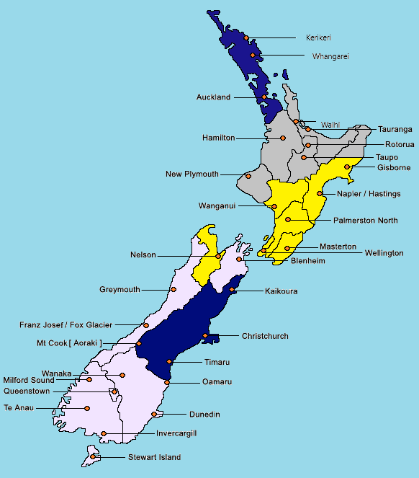
Conferences

